JAPAN: Eradicating Aum Shinrikyo’s Legacy of Toxic Terror
AUGUST 2018

CBRN DIGEST
Guest Author: Dr. Ajey Lele, Senior Fellow, Institute for Defence Studies and Analyses, New Delhi.
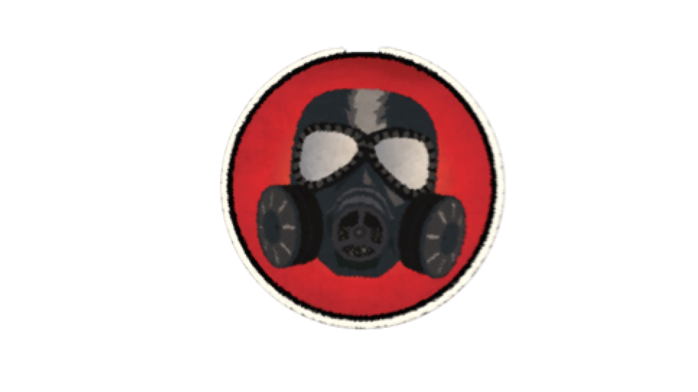
Monthly newsletter on Chemical, Biological, Radiological, Nuclear Weapons, Materials, Proliferation, Environmental and Humanitarian issues.

For years, Japan is known as technologically most advanced country in the world. However, even this country has not been free from cultural and religious fundamentalism and fanaticism.
During 1980s, a person calling himself as Shoko Asahara had formed a religious cult called Aum Shinrikyo ("supreme truth"), who had a support of many followers. He gained credibility by appearing on TV and on magazine covers. His claim to fame was his so-called ability to take others' sins upon himself. He also claimed that he could transfer spiritual power to his followers (had at least 10,000 members at its peak). He also moved towards claiming dark conspiracies everywhere by people from different religions and various royal families in the world.
He sketched a doomsday prophecy, like a third World War, and described a final conflict culminating in a nuclear Armageddon (a dramatic and catastrophic conflict, likely to destroy the world or the human race). He made his supporters believe that under such scenario, only they would survive. Actually, he even preached the necessity of Armageddon for "human relief". He started conducting terrorist attacks with some vague idea of beginning a process to finish humanity except his followers.
As weapons of mass murder, he started investing heavily in biological and chemical weapons. Aum Shinrikyo members perpetrated a mass murder in Matsumoto City in 1994, where they used Sarin as a chemical weapon to poison approximately 500 civilians, seven deaths were reported. On March 20, 1995, members of Aum Shinrikyo attacked the Tokyo subway with the nerve gas Sarin. Thirteen people died and around 6,000 more suffered from related ill-effects. For the brazen acts of terrorism and mass murder, Shoko Asahara was executed by hanging on July 6, 2018, at the Tokyo Detention House, 23 years after the Sarin gas attack, along with six other cult members. Twenty days later, on July 26, six remaining members of the cult on death row were executed. Some parts of Japan were kept on high alert during that period, since even today Shoko Asahara has some followers. His followers are known to have spread globally apart from Japan; particularly, in states which were the part of former Soviet Union. During 2016, police in Russia had conducted a number of raids on alleged cult members in Moscow and St Petersburg.
Japanese government had conducted a very detailed investigation of Tokyo subway attack and in fact much before the recent death sentences, from 2005 to 2011, 13 of Aum Shinrikyo senior members were sentenced to death. Aum Shinrikyo leaders are known to have obtained the idea to use Sarin from a Bulgarian book, “The Story of Poisons” (Authored by Vachivarov D, Nedelchef ), which was translated into Japanese by Yamazaki K, Kawanami in 1988. Highly educated people were attracted towards the philosophy of Shoko Asahara and one of his disciples was a brilliant chemist, who actually is known to have worked from scratch and ended up producing 30 kg of Sarin in the lab. Apart from chemical weapons, this group is also known to have worked on biological weapons too. Luckily, they were not able to get much of a success in their efforts. They experimented with the Botulinum toxin, one of the most toxic poisons, but failed to achieve much. Another biological warfare agent produced by them was the bacterium of Bacillus Anthrax. The choice of person made by Shoko Asahara to this experimentation was possibly not correct. This scientist did not know anything about bacteriology, since he was a virologist. Members of the cult are also known to have made several failed attempts to release hydrogen cyanide in various stations.
Today, discussing the execution of Shoko Asahara is not only relevant from the historical perspective, but it is important to keep the debate alive on this subject since the threat from chemical weapons still exist. For centuries, human ingenuity is known to have turned natural and synthetic poisons into weapons of war. Agents like phosgene, chlorine, and mustard gas are known to have been developed into chemical weapons. In recent history, the First World War (1914-1918) saw significant amount of usage of chemical weapons and even today, such weapons have been found to be used in Syrian theatre since 2012 and last attack by using these weapons happened during April 2018 (at Douma, killing at least 42 people).
There is a United Nations backed Chemical Weapons Convention which is in place since 1992 and is considered as one of the most successful convention with almost all the states in the world (including Syria) signatories to his convention. As per this convention no states are supposed to hold any chemical weapons with them. While signing this accord only around eight to nine states had declared possession of chemical weapons with them. Today, the US is the only country which is yet to finish the total destruction of their old weapon stockpiles (the process is on).
For all these years apart from the attack by Aum Shinrikyo, smaller number of chemical terrorism attacks has taken place. However, this does not guaranty that such attacks would not happen in future. The recent hanging of the culprits’ of 1995 attack and the use of chemical weapons in Syria reminds us that the possibility of doomed day scenario owing to large scale chemical weapons attack may not exist anymore, still the world cannot be declared free from the threat of chemical weapons.
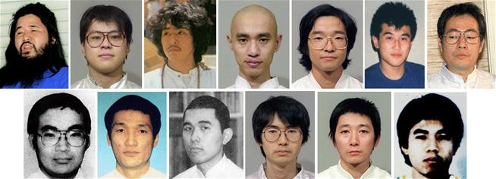
Shoko Asahara was executed by hanging on July 6, 2018, at the Tokyo Detention House, 23 years after the Sarin gas attack, along with six other cult members. On July 26, six remaining members of the cult on death row were executed.”

CBRN News Update: JULY 2018

CHEMICAL: “Chemical weapons agency finds 'chlorinated' chemicals in Syria's Douma”
Reuters, July 06, 2018
A preliminary report by the world’s chemical weapons watchdog said “various chlorinated chemicals” were found at the site of an attack in Douma, Syria, in April that killed dozens of civilians and prompted air strikes by Britain, France and the United States, it said on Friday. The Organization for the Prohibition of Chemical Weapons (OPCW) sent a fact-finding mission to Douma in mid-April, roughly a week after the April 7 attack in the enclave near Damascus.“Along with explosive residues, various chlorinated organic chemicals were found in samples from two sites,” it said, indicating that chlorine may have been used as a weapon. The OPCW said that its team was continuing its work to establish the significance of the results.
The OPCW has documented systematic use of banned munitions in Syria’s civil war, including nerve agent sarin and sulfur mustard gas. It has not assigned blame for the attacks. In Douma, OPCW inspectors visited two sites where they interviewed witnesses and took samples, which were split at their laboratory in the Netherlands and forwarded to affiliated national labs for testing. Samples recovered from one gas cylinder and near a second tested positive for chlorinated organic chemicals, the report said.
Washington and other Western governments blamed Syrian government forces for the attack in Douma. The Syrian government denies using chemical weapons during the country’s long civil war but the previous joint inquiry of the United Nations and the OPCW found the Syrian government used the nerve agent sarin in an April 2017 attack and has also several times used chlorine as a weapon. It blamed Islamic State militants for mustard gas use.

CHEMICAL: “OPCW Issues Fact-Finding Mission Reports on Chemical Weapons Use Allegations in Douma, Syria in 2018 and in Al-Hamadaniya and Karm Al-Tarrab in 2016”
OPCW, July 06, 2018
The Fact-Finding Mission (FFM) of the Organisation for the Prohibition of Chemical Weapons (OPCW), issued an interim report on the FFM’s investigation to date regarding the allegations of chemical weapons use in Douma, Syria on 7 April 2018. The FFM’s activities in Douma included on-site visits to collect environmental samples, interviews with witnesses, data collection. In a neighbouring country, the FFM team gathered or received biological and environmental samples, and conducted witness interviews.
“The OPCW Fact-Finding Mission issued a report on 2 July 2018 addressing allegations of chemical weapons use in Al-Hamadaniya, Syria on 30 October 2016, and Karm al-Tarrab, Syria on 13 November 2016”

OPCW designated labs conducted analysis of prioritised samples. The results show that no organophosphorous nerve agents or their degradation products were detected in the environmental samples or in the plasma samples taken from alleged casualties. Along with explosive residues, various chlorinated organic chemicals were found in samples from two sites, for which there is full chain of custody. Work by the team to establish the significance of these results is on-going. The FFM team will continue its work to draw final conclusions.
The Fact-Finding Mission also issued a report on 2 July 2018 addressing allegations of chemical weapons use in Al-Hamadaniya, Syria on 30 October 2016, and Karm al-Tarrab, Syria on 13 November 2016. On the basis of the information received and analysed, the prevailing narrative of the interviews, and the results of the laboratory analyses, the FFM cannot confidently determine whether or not a specific chemical was used as a weapon in the incidents that took place in the neighbourhood of Al-Hamadaniyah and in the area of Karm al-Tarrab. The FFM noted that the persons affected in the reported incidents may, in some instances, have been exposed to some type of non-persistent, irritating substance.
The FFM’s reports on the allegations of chemical weapons use in Douma, Al-Hamadaniya, and Karm Al-Tarrab have been shared with States Parties to the Chemical Weapons Convention. The reports were also transmitted to the UN Security Council through the UN Secretary-General.

CHEMICAL: “US, France Sanction Entities Tied to Syrian Chemical Weapons”
VoA News, July 25, 2018
The United States and France have imposed sanctions upon groups and individuals with links to Syria's chemical weapons program, the U.S. Treasury Department said Wednesday. "Syria's horrific use of chemical weapons, including attacks against innocent women and children, remains deeply embedded in our minds," said Sigal Mandelker, treasury undersecretary for terrorism, said in a statement. "Today, we are continuing our campaign to stop the Assad regime's ruthless attacks by targeting the procurement networks that have supported its chemical weapons program."
According to the statement, the United States will block five entities and eight individuals who have been part of a network supplying electronics to Syria's chemical weapons program. On Sunday, France froze the assets of 24 individuals in the same network, the statement read. One entity that Treasury sanctioned is Electronics Katrangi Trading, a Lebanese electronics retailer. Two of the individuals sanctioned by the department were former residents of Massachusetts. The Syrian government has long received criticism for its alleged use of chemical weapons against its own civilians amid the nation's civil war. The Syrian government and Russia, its ally, have denied these claims.
In April, over 70 people were killed in a suspected chemical attack in the Syrian city of Douma, a rebel-held town. An interim report released in July by the Organization for the Prohibition of Chemical Weapons, an intergovernmental chemical weapons watchdog, found "explosive residues [and] various chlorinated organic chemicals" on the site. As a response to the April attacks, the U.S., French and British governments launched a missile strike on suspected chemical weapon sites in Syria. "If the Syrian regime uses this poisonous gas again, the United States is locked and loaded," Nikki Haley, the U.S. ambassador to the United Nations, said in April.
BIOLOGICAL: “Cologne ricin plotters bought a hamster to test biological weapon”
DW, July 24, 2018
German prosecutors have arrested the wife of a Tunisian man detained last month over a biological attack plot. The couple allegedly bought a hamster to test a chemical substance ahead of a planned terrorist attack. The wife of a Tunisian man who was detained last month over a ricin-based biological weapon plot was also arrested on Tuesday on suspicion of being an accomplice. German federal prosecutors said the 43-year-old German woman, named only as Yasmin H, was suspected of helping prepare an act of violence and helping produce biological weapons. Her husband, Sief Allah H. was arrested on June 12 for "planning a serious act of violent subversion."
Prosecutors allege that Yasmin H, reportedly a convert to Islam, allowed her husband to use her online accounts to order ingredients to make ricin. The couple allegedly then bought a hamster to test the effectiveness of the toxin. On Tuesday, prosecutors said Yasmin H. had organized also a trip to Poland for her husband in late 2017 to buy explosive materials.
Islamist connection: Sief Allah H. was thought to have followed instructions on making a ricin bomb disseminated online by Islamic State (IS). Prosecutors said that — although he started buying the equipment and ingredients to make ricin in mid-May, including thousands of "castor seeds and an electric coffee grinder" — they still lacked specific details of an attack plan.
Biological weapon: According to federal prosecutors, about 3,150 castor bean seeds — more than three times the number initially suspected — and 84.3 milligrams of ricin were found in the suspect's apartment. Ricin is 6,000 times more potent than cyanide and is lethal in minute doses if swallowed, inhaled or injected. It has no known antidote.
“Ricin is 6,000 times more potent than cyanide and is lethal in minute doses if swallowed, inhaled or injected. It has no known antidote”

NUCLEAR: “Russia releases videos hyping its new hypersonic weapons just days after Putin and Trump meet.”

CNBC, July 20, 2018
Russia's Ministry of Defense released videos on Thursday showing new strategic weapons, most of which the U.S. cannot currently defend against. The new videos come on the heels of President Donald Trump's meeting with Russian President Vladimir Putin in the Finnish capital, Helsinki. The videos from the Kremlin's Ministry of Defense that went live Thursday appear to show a hypersonic air-to-ground missile, a new intercontinental ballistic missile, a nuclear-powered missile with unlimited range, and a hypersonic missile that can carry a nuclear warhead, as well as a few other systems.The weapons displayed in the videos are a significant addition to the Kremlin's arsenal, which already has more nuclear weapons than other countries, according to estimates. The latest revelations of Moscow's development of hypersonic weapons has sparked new fears over a budding arms race.
In March 2018, the Russian leader touted his nation's hypersonic weapons as "invincible" during a state of the nation address. "I want to tell all those who have fueled the arms race over the last 15 years, sought to win unilateral advantages over Russia, introduced unlawful sanctions aimed to contain our country's development: You have failed to contain Russia," Putin said during his address.
NUCLEAR: “Nobuo Tanaka, Former-IEA official: Nuclear power can’t compete with solar power”
THE ASAHI SHIMBUN, July 24, 2018
Nuclear power is "ridiculously expensive" compared with solar power and cannot compete from a financial standpoint, said the former head of the International Energy Agency. During a lecture at a symposium in Tokyo on July 23, Nobuo Tanaka, former IEA executive director, said nuclear power is utterly "uncompetitive" with solar power generation in terms of costs for building or expanding nuclear plants. “I was greatly shocked to hear that the IEA say that ‘solar becomes the cheapest source of electricity generation in many countries’ in its 2017 report,” said Tanaka, a well-known nuclear power advocate. He has served as an executive board member of the Japan Atomic Industrial Forum Inc., which comprises nuclear plant manufacturers.
Costs for nuclear power plants have been on the rise since the 2011 Great East Japan Earthquake and tsunami that crippled the Fukushima No. 1 nuclear power plant, operated by Tokyo Electric Power Co., and necessitated stricter safety measures. “Building a new nuclear power plant is ridiculously expensive as it will cost more than 1 trillion yen ($8.98 billion) to install just one nuclear power reactor,” said Tanaka. “It’s utterly uncompetitive.”Tanaka also pointed out that the resumption of the Kashiwazaki-Kariwa nuclear power plant in Niigata Prefecture seems to be “difficult” because the deadlock in approval to restart the plant is the result of a “lack of public understanding.”
“Building a new nuclear power plant is ridiculously expensive as it will cost more than 1 trillion yen ($8.98 billion) to install just one nuclear power reactor. “It’s utterly uncompetitive.” Nobuo Tanaka, former IEA executive director.

NUCLEAR: “North Korea is continuing to produce nuclear bomb fuel: Mike Pompeo”
Reuters, July 26, 2018
North Korea is continuing to produce fissile material for nuclear bombs in spite of its pledge to denuclearize, U.S. Secretary of State Mike Pompeo said on Wednesday. Asked at a Senate committee hearing whether this was the case, Pompeo responded to Democratic Senator Ed Markey by saying: “Yes, that’s correct ... Yes, they continue to produce fissile material.” Pompeo declined to respond when asked whether North Korea was continuing to pursue submarine-launched ballistic missiles or whether North Korea’s nuclear program was advancing generally. Pompeo said he would be happy to answer the latter question if necessary in a classified setting but suggested public statements on the issue would not help “a complex negotiation with a difficult adversary.”

NON-PROLIFERATION: “UN Chief Marks 50 Years Since NPT Signing”

VoA News, July 01, 2018
The United Nations Secretary-General Antonio Guterres on Sunday hailed the 50th anniversary of the signing of the Treaty on the Non-Proliferation of Nuclear Weapons (NPT). Marking the date, Guterres in a statement said, “The NPT is an essential pillar of international peace and security, and the heart of the nuclear disarmament and non-proliferation regime. Its unique status is based on its near universal membership, legally-binding obligations on disarmament, verifiable non-proliferation safeguards regime, and commitment to the peaceful use of nuclear energy." The treaty was signed July 1, 1968. It came into force in 1970 and it was extended indefinitely in May of 1995. The objective of the international treaty is to stop the spread of nuclear weapons and weapons-making technology, allow its signatories to pursue nuclear energy for peaceful purposes, and phase out the nuclear arsenal of the five original nuclear powers - China, France, Russia, the United Kingdom and the U.S. Most of the world, as 191 countries have signed the NPT. The holdouts are India, Pakistan, Israel and South Sudan. North Korea withdrew from the treaty in 2003. North Korea, India and Pakistan have publicly disclosed their weapons program and Israel has long maintained a policy of deliberate ambiguity. The treaty establishes a safeguards system that is overseen by the International Atomic Energy Agency (IAEA). The agency uses inspections as a means to verify compliance of the treaty by member states.
_______________________________________________________________
The CBRN Digest aims to document the trends and developments relating to Chemical, Biological, Radiological and Nuclear weapons and their proliferations. The Digest is scheduled to be published at the beginning of each calendar month, assessing events and developments of the previous month.

Editor: Animesh Roul (Executive Director, Society for the Study of Peace and Conflict, New Delhi)

About SSPC
The Society for the Study of Peace and Conflict (SSPC) is an independent, non-profit, non-partisan research organization based in New Delhi, dedicated to conduct rigorous and comprehensive research, and work towards disseminating information through commentaries and analyses on a broad spectrum of issues relating to peace, conflict and human development. SSPC has been registered under the Societies Registration Act (XXI) of 1860. The SSPC came into being as a platform to exchange ideas, to undertake quality research, and to ensure a fruitful dialogue.

Copyright © 2018: Society for the Study of Peace and Conflict, New Delhi

We welcome your feedback. Email your comments at sspconline@gmail.com
To Subscribe or to sponsor this product, please contact: Coordinator, Society for the Study of Peace and Conflict, New Delhi: sspconline@gmail.com. Subscriptions are free and require only an email address.

The CBRN Digest / Published by: Society for the Study of Peace and Conflict. Post Box: 10560, JNU Old Campus, New Delhi-110067. Website: www.sspconline.org : Twitter:@sspconline

