CBRN Digest
No 1: March, 2015
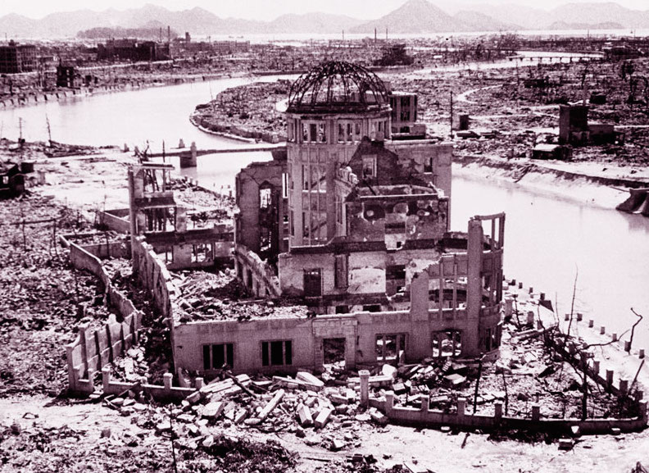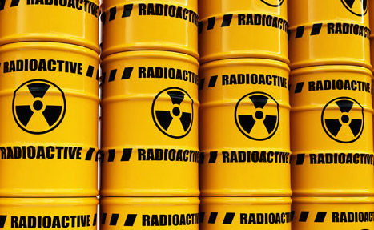
Monthly newsletter on Chemical, Biological, Radiological, Nuclear Weapons, Materials, Proliferation, Environmental and Humanitarian issues.

Society for the study of peace and conflict, new delhi
www.sspconline.org
© 2015

March 2015
Brief:
- Chlorine in Sarmin: Specter of Chemical Warfare in Syria
Pages of History:
- Bravo in Bikini: Fallout of Largest H-Bomb Test
CBRN News:
- UN News Center, March 26, 2015: “We must remain vigilant,’ Ban urges as Biological Weapons Convention turns 40”.
- Reuters March 26, 2015: “Chemical weapons body (OPCW) to investigate allegations of chlorine gas attacks in Syrian villages”.
- AFP / Times of India, March 23, 2015: “Hit by Nuclear weapon testing, Bikini Islanders seek refuge in US”.
- Reuters, March 21, 2015: “North Korea says can fire nuclear missile at any time”.
- VoA News, April 01, 2015: “N. Korean Envoy: Nuclear Weapons Not Negotiable”.
- The National (UAE) March 20, 2015: “Former IAEA chief hopes for nuclear weapon-free Middle East”.
- Nation (Lahore), March 25, 2015: “Pakistan’s tactical nukes to deter India: Khalid Kidwai”.
- The News (Warsaw), March 10, 2015: “Stolen radioactive cobalt still at large”.
- Wall Street Journal, March 27, 2015: “Iran Keeps Its Nuclear Secrets”.
Analysis:

Chlorine in Sarmin: Specter of Chemical Warfare in Syria
The United Nations has already confirmed the indiscriminate use of chemical weapons against civilians in the ongoing Syrian Civil War. Host of independent agencies and other sources active on the ground too have verified this dastardly act. In the last few years, there have been many cases of chemical weapon attacks. Some of these incidents have been investigated and confirmed by leading world agencies (like UNHCR and Human Right Watch), while some other cases remain controversial or under-reported. The most deadliest attack took place in Khan al-Asal (March 2013) and in Ghouta (August 2013) where various estimates suggest that not less than a couple of thousand people died and scores bore the brunt of the deadly gases. The UN and Russians led separate investigations and confirmed the use of Sarin nerve agent and chlorine in both the attacks; they could not, however, ascertain the perpetrators of the crime -- whether it was the government that was behind these attacks or the rebels/militant groups.
Almost two years after Khan al Asal incident, which took place on March 16 (2015), once again the specter of chemical weapon returned to haunt inhabitants of Sarmin (Idlib province) in the northwestern Syria. There were allegations and counter allegations regarding this. Syrian opposition group, however, claimed that Bashar al-Assad’s government carried out the chlorine gas attack in Sarmin, while the Syrian regime denied any such responsibility outrightly.
The UK based Syrian Observatory for Human Rights (SOHR), which has been at the forefront of carrying out information warfare (though not propaganda) against the incumbent regime in Syria, was the first to inform about the death of one family, including three children, after the barrel bomb filled with gas was thrown at the town of Sarmin in southeast Idlib province. Other independent sources and media reports confirmed the use of chlorine in Sarmin locality subsequently. Videos and pictures from the hospitals located at the epicentre of the target suggested the possible gas attack. The most notable report came from international medical humanitarian agency, Médecins Sans Frontières (MSF) in which the agency citing doctors engaged in providing medical treatments to the victims claimed the possible chlorine attack in northwestern Syria that killed at least six and affected nearly 70 people. The medical conditions of those affected by the gas were described in the MSF report read, “Patients are in serious condition, agitated, foaming blood at the mouth, and displaying skin rashes”.
Few weeks before the Sarmin chemical incident, the UN Security Council (UNSC) adopted a resolution condemning the use of any toxic chemicals, including chlorine, as a weapon in Syria on March 06, 2015. The UNSC, taking cognizance of the fact finding report by the Organisation for the Prohibition of Chemical Weapon (OPCW), reiterated that the ‘use of toxic chemicals as a weapon would constitute a violation of Council resolution 2118 (2013)’, warned of strong measures if chemicals are used in future attacks; in other words, threatening direct action against further violations by any actors engaged in the conflict.
Even though Syria joined the OPCW in 2013 following the deadly Ghouta attack and declared its chemical weapon arsenal, that were destroyed subsequently under international supervision, many fear that Syria still has undeclared arsenal, especially chlorine. Syria didn’t include chlorine stockpiles on its list of declared chemical weapons, as it does not fall under weapon category. Chlorine is known for its extensive industrial and sanitary use. But using chlorine against civilians or as a weapon of war is in complete violation of the 1925 Geneva Protocol, which Syria has ratified. The Geneva Protocol prohibits the “Use in War of Asphyxiating, Poisonous or other Gases” that certainly includes Chlorine. Not only Geneva Protocol or Chemical Weapons Convention, the use of chlorine as chemical weapon (post March 6, 2015) violates the UNSCRs 2118 (2013) and 2209 (2015). The UNSC Resolution 2209 has condemned the use of chlorine as a chemical weapon in Syria and made clear that such a violation would have consequences under Chapter VII of the UN Charter.
(SSPC Research)

Pages of History
Bravo in Bikini: Fallout of Largest H-Bomb Test

On March 1, 1954, the United States had detonated a hydrogen bomb (H-bomb or thermonuclear bomb) at Bikini Atoll located in the Republic of the Marshall Islands. The nuclear test was part of the Operation Castle and the device, codenamed ‘Bravo’, was the first of its kind tested ever in the human history by utilizing a dry (solid) fuel. The 15-megaton nuclear explosion had surpassed the previously estimated yield. It proved to be immensely powerful, even more than the atomic bombs that ravaged Japanese cities of Hiroshima and Nagasaki subsequently during World War II in August 1945.
This not only provided unexpectedly high yield, but caused massive damage to the environment and left a lingering radiological disaster in the islands. The crater created by Bravo itself in the Atoll had a diameter of 6510 ft, with a depth of 250 ft. Within ten minutes of the blast, the mushroom cloud reached its full dimensions with a diameter of 100 km and the cloud column reached 16.5 km high in the atmoshphere.
[Castle Bravo, largest thermonuclear nuclear device detonated at Bikini Atoll (The Marshall Islands) by the USA on March 1, 1954. [Image courtesy: atomcentral.com]

The Bravo H-Bomb created a massive radiological disaster that affected the whole of Marshallese Islanders primarily on Rongerik, Rongelap, Ailinginae and Utirik atolls. Five hours after the detonation, the fallout began at Rongelap Atoll. This fallout consisted mainly of mixed fission products with small quantities of neutron-induced radionuclides and traces of fissionable elements. About 24 hours later, the residents of Utirik were evacuated and after 50 hours the Navy evacuated the Rongelap population. The fallout was carried away by the wind to Rongerik, Uterik and a Japanese fishing vessel called Daigo Fukuryu Maru (Lucky Dragon 5), which was heavily contaminated, as the 23 crew members were exposed to 300 R (Roentgen unit). One of the affected crew members Aikichi Kuboyama died from liver complications while undergoing treatment for acute radiation syndrome (ARS) later that year thereby becoming the first victim of the H-Bomb.
This unfortunate consequence occurred primarily because of misjudgement of the meteorological situation and due to an unexpected change in wind direction. Even though the Bikini Atoll was uninhabited during that time, the 236 inhabitants of Rongelap and Utirik atolls were exposed to radiation. Among the immediate common complaints after drinking contaminated water were nausea, skin-burns, headaches, and numbness. About 90 percent of the people from Rongelap, whose hair became white with fallout ashes, experienced hair-loss. Long-term ailments included reports of miscarriages in women up to four years after the test and increase in hyperactive thyroid glands, thyroid cancer and leukemia. Besides, the displaced Bikini Islanders of Rongerik suffered from severe food shortages due to limited resources on the island.
A survey conducted by the US government estimated that the Bikini would not be habitable for next hundred years. In 1964, the US Government admitted responsibility for exposing the islanders to radiation and appropriated funds for compensation.

[Compilation: SSPC Research]
SELECTED READINGS:
Atomic Archive, “The BRAVO Test”, http://www.atomicarchive.com/History/coldwar/page06.shtml
L.W. Nordaeim, “Tests of Nuclear Weapon”. Bulletin of the Atomic Scientists, Vol. XI, No. 7, September 1955.
IPPNW and IEER, “Radioactive Heaven and Earth”, Apex Press, New York, 1991.
Ariana Rowberry , “Castle Bravo: The Largest U.S. Nuclear Explosion”, Brookings Blog, February 27, 2014.
Ōishi Matashichi, “The Day the Sun Rose in the West: Bikini, the Lucky Dragon, and I” (a fisherman’s account who was aboard ‘The Lucky Dragon #5’], University of Hawaii Press, May 2011.

CBRN News Update
UNITED NATION: “We must remain vigilant,’ Ban urges as Biological Weapons Convention turns 40”, UN News Center, March 26, 2015. URL: http://www.un.org/
The world must continue to remain vigilant against the threat of biological weapons despite the progress made by the international community in preventing their spread, United Nations Secretary-General Ban Ki-moon said on March 26 (Thursday). In a message marking the 40th anniversary of the entry into force of the UN Biological Weapons Convention, the Secretary-General noted that “the norm against the use and possession of biological weapons remains strong, and no country identifies itself as possessing biological weapons.”
The Biological Weapons Convention opened for signature in 1972 and entered into force in 1975. It prohibits the development, production, acquisition, transfer, retention, stockpiling and use of biological and toxin weapons and is a key element, along with the Nuclear Non-proliferation Treaty and the Chemical Weapons Convention, in the international community's efforts to address the proliferation of weapons of mass destruction. It was also the first multilateral disarmament treaty banning an entire category of weapons. It currently has 173 States parties. Mr. Ban called on the 23 governments that have not yet joined the Convention to do so “without delay,” adding that in its anniversary year, and with the Eighth Review Conference around the corner in 2016, “all countries should reaffirm their unequivocal rejection of the use of disease as a weapon.”
SYRIA:
“Chemical weapons body (OPCW) to investigate allegations of chlorine gas attacks in Syrian villages”, Reuters, March 26, 2015. URL: http://www.reuters.com
The global chemical weapons watchdog will investigate allegations of chlorine gas attacks in Syrian villages that killed six and wounded dozens this month, a source told Reuters on March 26 (Thursday). The source at the Organization for the Prohibition of Chemical Weapons (OPCW), who spoke on condition of anonymity, said a fact-finding mission will examine reports of several barrel bombs in the northwestern Idlib region. "It will be investigated," said the source, referring to the deadliest attack in the village of Sarmin, where a barrel bomb hit a home, reportedly killing two children, their parents and wounding 90 residents. The OPCW's fact-finding mission concluded last year that the use of chlorine gas is "systematic" in the four-year Syrian civil war, which has killed more than 200,000 people and displaced millions. Both sides have denied using chlorine "barrel" bombs, which the OPCW said are dropped out of helicopters. The Syrian air force is the only party in the conflict known to have helicopters.
Syria joined the Chemical Weapons Convention in 2013, agreeing to allow foreign weapons inspectors into the country and averting U.S.-threatened air strikes after sarin attacks in the outskirts of Damascus killed hundreds. The government of President Bashar al Assad has since handed over 1,300 tonnes of toxic chemicals and is destroying production and storage facilities. The process of verifying that the chemical weapons program has been eliminated is continuing.

REPUBLIC OF THE MARSHALL ISLANDS: “Hit by Nuclear weapon testing, Bikini Islanders seek refuge in US” , AFP / Times of India, March 23, 2015, URL: http://timesofindia.indiatimes.com/
A tiny central Pacific community, forced to evacuate their homes because of US nuclear testing, are now demanding refuge in the US as they face a new threat from climate change. "We want to relocate to the US," Nishma Jamore, mayor of the atoll of Bikini, said on the weekend as Pacific waters continued to eat away at the small Kili and Ejit islands in the far-flung Marshall Islands archipelago. Jamore heads a community of about 1,000 islanders who have lived in exile on the islands for decades because their original homeland of Bikini remains too radioactive for resettlement. There were 24 nuclear tests conducted on the atoll in the 1950s, including "Bravo", the largest hydrogen bomb detonation conducted by the US. Unable to return to Bikini, the islanders are now faced with increasingly heavy flooding from high tides and storms hitting Kili and Ejit with waves washing over the islands and wiping out food crops. Jamore voiced their concerns to US assistant secretary of interior Esther Kia'aina during her visit to the Marshall's capital of Majuro this month.
There is also serious concern over a recent legislative move by the Marshall's parliament, known as the Nitijela, to take authority for Ejit Island away from the Bikinians. The latest flooding at Kili hit last month during annual high tides, and Jamore described the island's airport runway as like "the Nile River". As the floods damaged houses and crops, the 1.6km long runway, which is 2.5m above sea level, disappeared beneath saltwater. The islanders have called a second time to be resettled in the US. ]

NORTH KOREA: “North Korea says can fire nuclear missile at any time”, Reuters, March 21, 2015, URL: http://www.reuters.com
North Korea has the ability to fire a nuclear weapon and would use a nuclear missile in retaliation if it is attacked, the country's ambassador to Britain told Sky News on Friday. "It is not the United States that has a monopoly on nuclear weapons strikes," Ambassador Hyun Hak-bong told Sky at the isolated Asian country's London embassy. Asked if that meant North Korea, which quit the nuclear Non-Proliferation Treaty in 1993, had the capability to fire a nuclear missile now, he replied: "Any time, any time, yes." "If the United States strike us, we should strike back. We are ready for conventional war with conventional war, we are ready for nuclear war with nuclear war. We do not want war but we are not afraid of war," he added.
In a speech on March 3, North Korean Foreign Minister Ri Su Yong said his country had the power to deter an "ever-increasing nuclear threat" by the United States with a pre-emptive strike if necessary. He also denounced military exercises staged by South Korea and the United States as provocative. The United States has said it is seriously concerned about North Korea's nuclear work, which it says breaches international agreements. North Korea has conducted three nuclear detonations, the most recent in February 2013, and the commander of U.S. forces in South Korea said in October he believed Pyongyang had the capability to build a nuclear warhead that can be mounted on a ballistic missile, although there had been no tests or other evidence to show it had taken that step.
NORTH KOREA: “N. Korean Envoy: Nuclear Weapons Not Negotiable”, VoA News, April 01, 2015, URL: http://www.voanews.com
A North Korean diplomat says his country’s nuclear weapons program is not subject to negotiation, rejecting a U.S. call for its denuclearization. The diplomat, from the North Korean mission to the United Nations in New York, told VOA Tuesday his country will not negotiate away its nuclear weapons. "Denuclearization should not be an objective of any future talks with us," said the official, who preferred to remain anonymous. "We will never give up nuclear weapons before the U.S. and the world are denuclearized." The diplomat reiterated Pyongyang’s longstanding position that it must have nuclear weapons to deter the U.S. threat, saying his country has no "expectations of negotiations as the U.S. is increasing its hostile policy" against North Korea. The State Department has dismissed the comments. A spokesman told VOA, "Multiple U.N. Security Council resolutions require North Korea to abandon all nuclear weapons and existing nuclear programs in a complete, verifiable and irreversible manner, and immediately cease all related activities." Six-party talks on North Korea's nuclear program have been stalled since 2008. Washington has said Pyongyang must show a commitment toward denuclearization before talks can resume, a position rejected by North Korea. The other participants, besides the United States, include China, Japan, Russia and South Korea. In February, South Korea’s top nuclear envoy said all participants in the North Korean nuclear talks except North Korea had reached a consensus to hold exploratory talks before resuming any formal six-party discussions. The U.S. and other nations in the talks have not commented directly on the announcement.
UNITED ARAB EMIRATES: “Former IAEA chief hopes for nuclear weapon-free Middle East”, The National (UAE) March 20, 2015 URL: http://www.thenational.ae
Dr Hans Blix, chairman of the advisory board of the UAE’s nuclear programme, said he hoped multinational talks on Iran’s nuclear future would work out and lead to a Middle East free of nuclear weapons. “I don’t think a conference can be reached at the moment but I’m very much in favour of [a nuclear-free Middle East],” he said during an exclusive interview with The National this week. One should not despair of a future that is more positive.” He said Israel, Saudi Arabia and Egypt would only be satisfied with a total absence of any nuclear enrichment from Iran. “However, the Non-Proliferation Treaty Conference in 2010 had a proposal for the creation of a zone free of weapons of mass destruction, including, notably, nuclear weapons, with the Finnish government as the host,” he said. “There was resistance from the Israeli side as they felt a conference focusing on nuclear weapons would inevitably focus on Israeli weapons, while they felt Iranian enrichment should have been focused on. We do not see that a conference will take place before the 2015 review conference next month.”
Hamad Alkaabi, the UAE permanent representative to the IAEA, said the project was long overdue. “The UAE maintained a strong position in support of such an objective, along with countries of the region,” he said. “Such a zone, once established, will significantly contribute to the peace and security of the region. It will build confidence and strengthen cooperation among regional countries.” He said it had been a major setback for the process so far. “The UAE was very disappointed with this lack of process despite the positive efforts,” said Mr Alkaabi. “The next NPT review conference, taking place in New York, will look at this issue again in detail. It is unfortunate that no decision yet is made on if and when such a delayed Middle East conference will take place.”
PAKISTAN: “Pakistan’s tactical nukes to deter India: Khalid Kidwai”, Nation (Lahore), March 25, 2015, URL: http://nation.com.pk
Pakistan opted for short-range "tactical" nuclear weapons in response to India's "offensive" Cold Start Doctrine, which states that there is space for conventional war even in a nuclearized environment, a Pakistani Adviser on Nuclear Security said on Monday, while maintaining that nuclear deterrence had helped prevent war in South Asia, "This was Pakistan's defensive response to an offensive doctrine," said Lt.Gen (Retd) Khalid Kidwai, who is Adviser to Pakistan’s National Command Authority (NCA) and pioneer Director-General of Pakistan’s Strategic Plans Division, which he headed for an unprecedented 15 years told a conference on nuclear security organised by the Carnegie Endowment for International Peace. Responding to questions, Kidwai, who was speaking at a conference on nuclear security organised by the Carnegie Endowment for International Peace, also said that Pakistan had developed the 2,750 km range Shaheen-3 missile to prevent India from gaining a second-strike nuclear capability from Andaman and Nicobar islands. The Adviser went on to state that one-sided policies of the United States favoring India – like the NSG (Nuclear Suppliers Group) exemption for the nuclear deal – have been a destabilizing factor for South Asia. “An even-handed and non-discriminatory approach to South Asia alone will contribute towards peace and stability. Discriminatory approach like NSC (Nuclear Suppliers Group) exemption and NSC membership is already proving to be counterproductive. It will never be acceptable to Pakistan, and in no way contribute to peace and stability. Let’s desist from short-sighted measures today, that we would regret later.” Kidwai also rejected concerns over the security of Pakistan's nuclear arsenal, insisting that adequate safeguards are in place to protect its assets. Pakistan takes its nuclear security obligations seriously in the disturbed climate in the region, he said. Kidwai said replying to a question, that having tactical weapons would make war less likely. He said given the strength of the rest of Pakistan's nuclear arsenal, the fear of "mutually assured destruction" of the South Asian rivals would ensure that "sanity prevails.

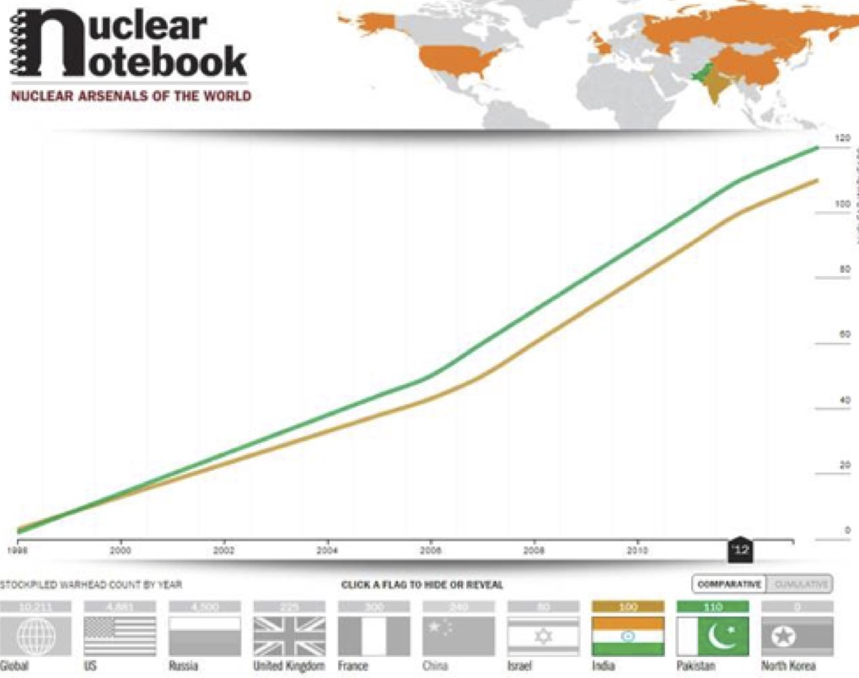
[In March 2015, an infographic created by the Bulletin of Atomic Scientists reveals that Pakistan is ahead of India in the nuclear arms race by 10 atomic weapons. While India has 110 atomic weapons, Pakistan possesses 120. Image Courtesy: Bulletin of Atomic Scientists (Nuclear Notebook)
POLAND: “Stolen radioactive cobalt still at large”, The News (Warsaw), March 10, 2015, URL: http://www.thenews.pl/
The 22 lead containers of radioactive Cobalt-60 were stolen on March 06 (Friday) from a warehouse in Poznań in west-central Poland. “The information we obtained indicates that the source of ionising radiation, cobalt isotope Co-60, was in closed containers that are tamper-proof and [until opened] do not constitute a threat to the health of people,” Tomasz Stube, spokesperson to the Wielkopolska Provincial Office, told Polish Radio. According to media sources, the Co-60 was in Ps-5b and PRJ-100 containers weighing 45 and 70kg respectively. On February 10, at the same Poznań warehouse thieves took away around a metric tonne of lead nuggets. This could be used to produce the casings for the radioactive substance which was stolen in a later break-in. On the night between Sunday and Monday, three people were detained in connection with the lead theft, but the radioactive material has not yet been found. The police has announced a reward of PLN 5,000 (EUR1,200; USD 1,300) for information leading to arrests in the case.
Iran: “Iran Keeps Its Nuclear Secrets”, Wall Street Journal, March 27, 2015, http://www.wsj.com
With days to go until the deadline for the Iran nuclear talks, the list of the skeptical is growing. The latest addition is the International Atomic Energy Agency, and its misgivings are a reality check on Iran’s willingness to honor its promises. Progress has been very limited on Iran’s promise to come clean about its earlier efforts to develop a nuclear weapon, IAEA head Yukiya Amano said this week. Mr. Amano added that “no more new issues” had been resolved, particularly on Iran’s effort to develop explosives for a nuke. Supporters of the talks hailed last year’s Iranian-IAEA statement, in which Tehran pledged to fess up to its weaponization work. That statement followed a 2013 agreement setting out a 12-step plan for disclosing the possible military dimensions of a nuclear program Tehran still claims is for civilian use. Tehran would clean the slate about the past, the thinking went, and trust would grow. Now Mr. Amano says Tehran has completed only one of the 12 steps.
Western intelligence agencies believe the regime tried to develop a nuclear explosive device beginning in the 1980s. Tehran in subsequent years consolidated its weaponization work in the “AMAD Plan,” led by Mohsen Fakhrizadeh, a Ph.D. nuclear scientist and senior member of the Islamic Revolutionary Guard Corps. Mr. Fakhrizadeh’s team procured dual-use technologies, developed detonators and conducted high-explosive experiments until 2003, when the AMAD Plan was halted, according to Western intelligence. The apparent pause came after the 2002 disclosure of two secret nuclear sites—the event that set off the Iranian nuclear crisis—and the subsequent U.S. invasion of Iraq. But as former U.N. weapons inspector David Albright told last year, “Fakhrizadeh continued to run the program in the military industry.” The AMAD Plan’s latest iteration is the Organization of Defensive Innovation and Research, known to the West by its Persian acronym, SPND. Iran has long withheld information about the SPND and its predecessor entities, and it has refused to make Mr. Fakhrizadeh available for IAEA interviews. Without Iranian disclosure of past illicit activities, including nuclear enrichment and weaponization research, it’s hard to see how the Obama Administration can honor its core pledge to strike a deal that would give the West a one-year warning if Iran decides to build a bomb. As Olli Heinonen, the former Deputy Director-General for Safeguards at the IAEA, told us, “you need to have that baseline. You want to understand what they were doing.” An Iran that has the know-how to rapidly weaponize highly enriched uranium or plutonium may need only months to assemble a bomb.

Published by: Society for the Study of Peace and Conflict. Post Box: 10560, JNU Old Campus, New Delhi-110067.
Website: www.sspconline.org
Twitter: https://twitter.com/sspconline
Facebook: https://www.facebook.com/sspconline

To Subscribe or to sponsor this product, please contact: Coordinator, Society for the Study of Peace and Conflict, New Delhi: sspconline@gmail.com
Subscriptions are free and require only an email address.
Copyright © 2015 SSPC

